**Enumeration (or enum) in C**

* Difficulty Level : [Easy](https://www.geeksforgeeks.org/easy/)
* Last Updated : 20 Jul, 2021

Enumeration (or enum) is a user defined data type in C. It is mainly used to assign names to integral constants, the names make a program easy to read and maintain.

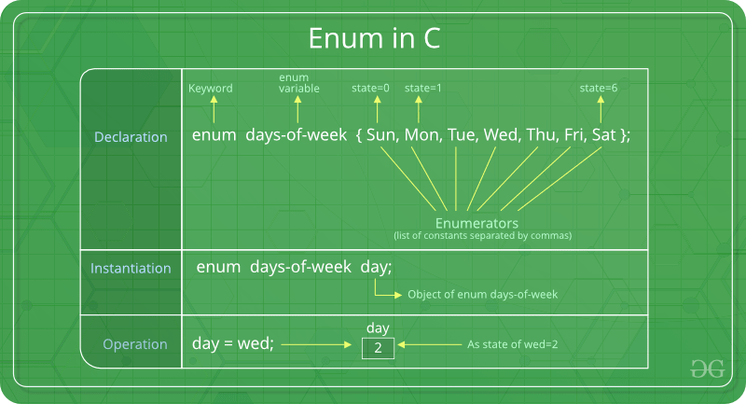

enum State {Working = 1, Failed = 0};

The keyword ‘enum’ is used to declare new enumeration types in C and C++. Following is an example of enum declaration.

// The name of enumeration is "flag" and the constant

// are the values of the flag. By default, the values

// of the constants are as follows:

// constant1 = 0, constant2 = 1, constant3 = 2 and

// so on.

enum flag{constant1, constant2, constant3, ....... };

Variables of type enum can also be defined. They can be defined in two ways:

// In both of the below cases, "day" is

// defined as the variable of type week.

enum week{Mon, Tue, Wed};

enum week day;

// **Or**

enum week{Mon, Tue, Wed}day;